Label the food plate areas. | Fruit  Vegetable  Grain  Protein  Dairy
What is the MINERAL needed to build strong bones. | calcium
Is water a nutrient needed to have a healthy diet? | YES
Is a calorie a measure of energy? | YES
Is the ingredient that is the most by weight listed first or last in order on the food label? | FIRST

If a person usually eats 2000 calories a day and uses 2000 calories, will the person stay the same weight? | YES
Is a diet high in cholesterol and fat healthy? What can they lead to? | NO  Cholesterol and fat can lead to diabetes and heart disease.
What two things do you need to do every day to keep your body healthy? | Exercise and eat healthy foods.
Which food is healthier in the grain group, a whole grain roll or a chocolate chip muffin? | Whole Grain Roll
Which food is healthier in the vegetable group,  spinach or French fries? | Spinach

Which food is healthier in the dairy group, a milkshake or skim milk? | Skim Milk
Which food is healthier in the protein group, fried chicken or salmon? | Salmon
Which food is healthier in the fruit group, fresh bananas or canned fruit in syrup? | Fresh bananas
Looking at the food label, what is one serving size? | 5 crackers
Looking at the food label, how many servings are in the package? | 28

Looking at the food label, how many total fat grams are in one serving? | 4.5 grams
Looking at the food label, what percentage of daily total fat are from one serving of this food? | 7%
Looking at the food label, how many crackers are in one serving. | 5
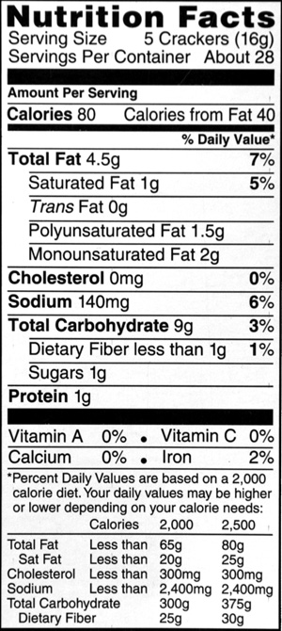 | Food Label

What is the name of the nutrient that is used for energy and heat that you should eat in limited amounts? | fat

What nutrient begins with a V that is needed for fighting infections, good vision, healthy skin, and strong bones and teeth? | Vitamins

What nutrient helps build strong muscles? | Protein

